

Learning@NHSWales

NHS Wales User Guide
Digital Learning Wales

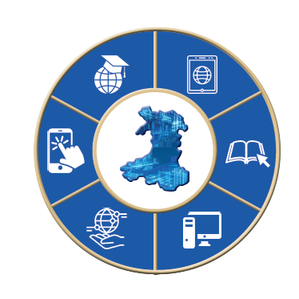

User GuidE for Perinatal & Infant Mental Health Awareness Training.

To access the Perinatal & Infant Mental Health Awareness Training, you will first need to log into your account, please follow this link https://learning.nhs.wales/login/index.php
Here, you will be asked to enter your log in details.
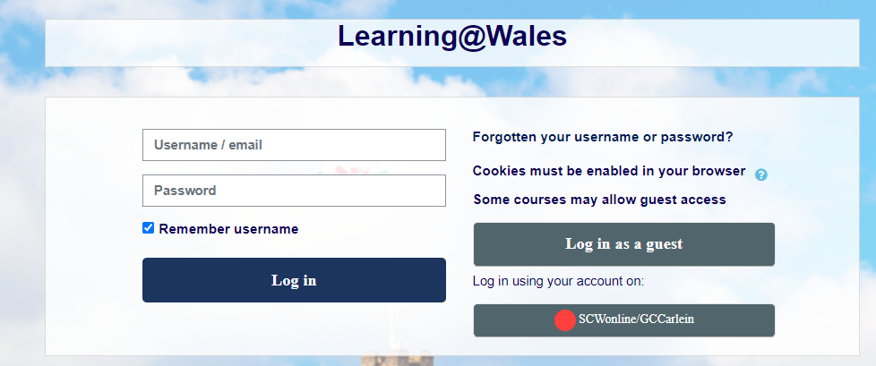
If you do not know your log in details, you can contact the Digital Learning Wales Helpdesk. You can either contact them via the live chat, which is found at the bottom right of the webpage. 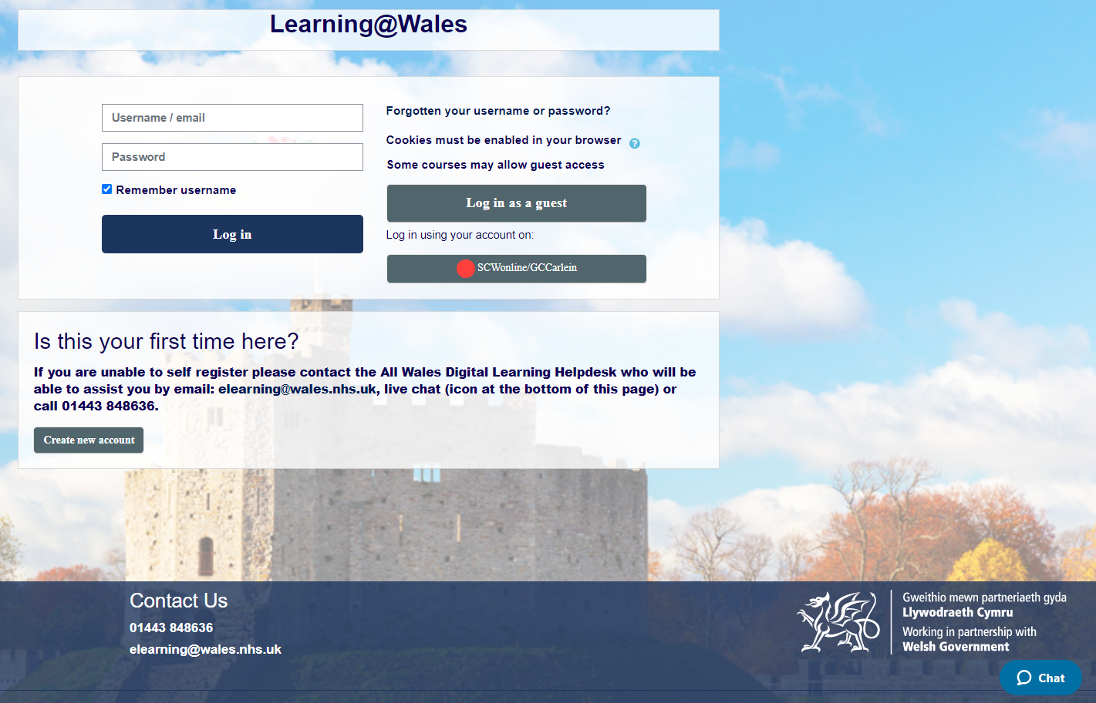
Or you can contact the helpdesk via 01443 848636 or elearning@wales.nhs.uk
Once you have logged into your account, you can then access the Perinatal & Infant Mental Health Awareness Training via this link - https://learning.nhs.wales/course/view.php?id=991
NOTICE: Before you access the course, you will NEED to enter your enrolment key. 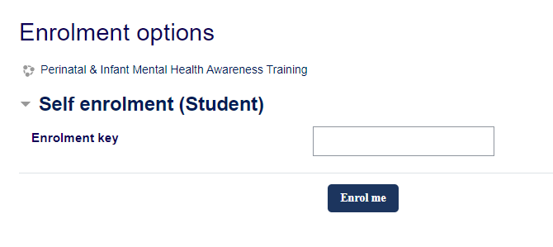
Again, if you are ever unsure of what your enrolment key is you can contact the helpdesk via the live chat or with the contact details above.

Once you have entered the correct key, you will have access to the modules.
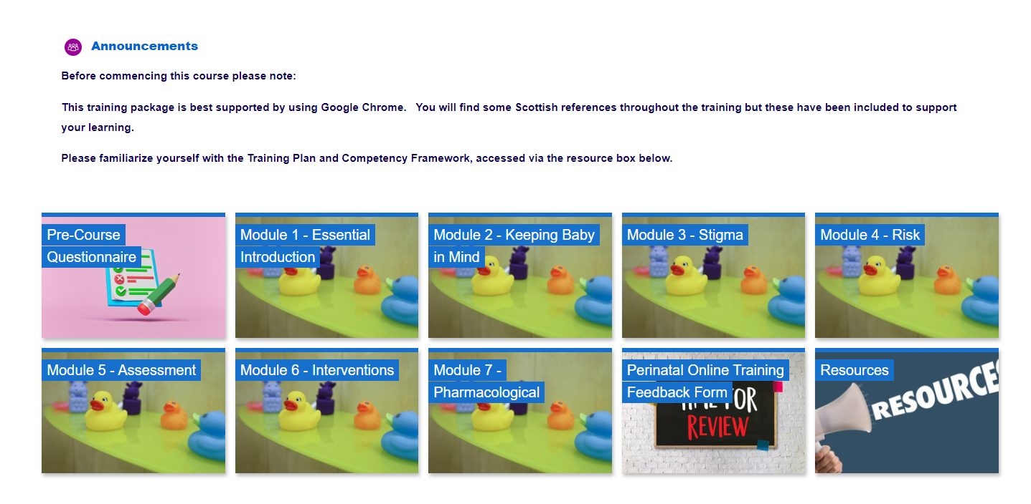

Live chat at the bottom right of the website, 01443 848636 or elearning@wales.nhs.uk

9:00am – 4:45pm

Contact the eLearning Help desk:

01443 848636 or elearning@wales.nhs.uk

8.45am – 4.45pm

